IIF Inaugurates its New Building at Delhi
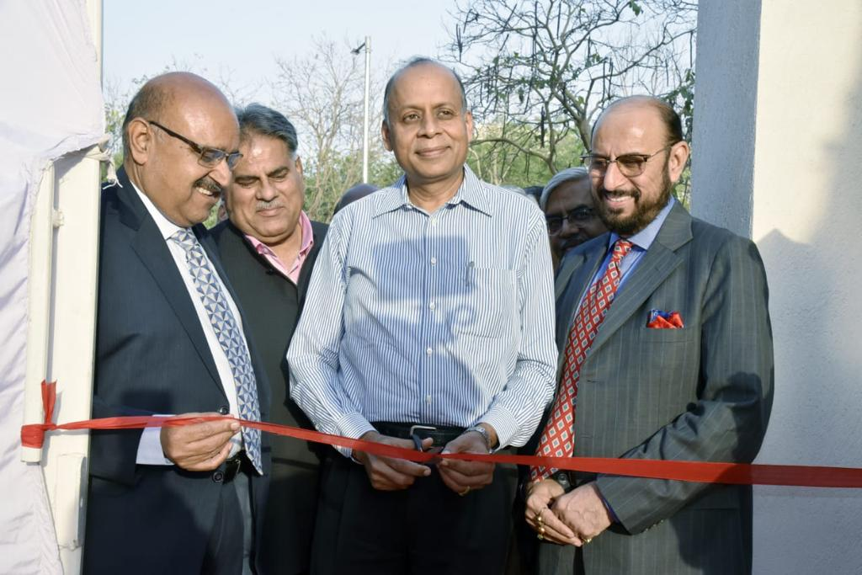

Dr. Ajay Kumar, Secretary Defence Production inaugurating the New IIF Building by ceremonial ribbon cutting

To meet the growing requirements of infrastructure in order to deliver improved & value added services to the industry and its members, The Institute of Indian Foundrymen (IIF) have constructed a modern 4 storey office Building at 67, Tughlakabad Institutional Area, New Delhi which was inaugurated on Friday, 12th April 2019 by the Chief Guest, Secretary Defence Production, Dr. Ajay Kumar in the august presence of Guest of Honor Shri, Ravi Sehgal, Chairman- EEPC & Shri. P Udayakumar, Director (P&M), NSIC, Shri Shashi Kumar Jain, President-IIF & other National Office Bearers-IIF, Past Presidents-IIF, National Council Members-IIF among other invited guests from Government, Industry Associations, foundry & associated industries.

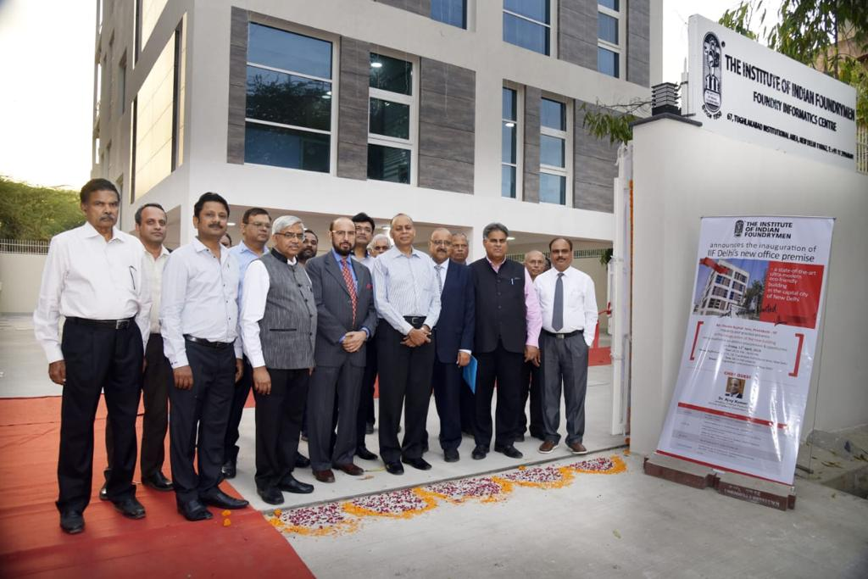
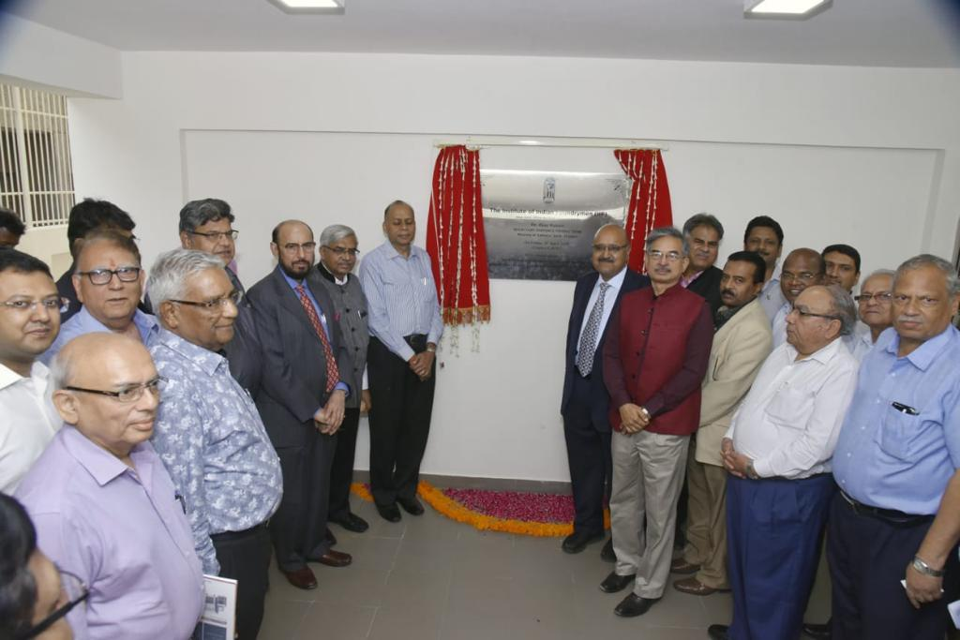
Shri Naresh Garg, Past President-IIF welcomed the guests and explained them about the building and its unique features. He praised the efforts of the building committee members, contractors and IIF officials and thanked the IIF NOBs for their support which was instrumental in timely completion of the building. Afterwards, President-IIF, Shri Shashi Kumar Jain addressed the gathering. He informed about various initiatives taken by the IIF for the benefit of the industry and how the infrastructure created by IIF will add on to the strength of IIF in enhancing its capabilities to serve the industry.

There was a special screening of video “I am Proud to be Foundrymen” which showcased the importance of foundries not only to the industry but to the society as whole and how foundries are associated with every important aspect of life of common people.

After that, Shri D. K. Bangotra, GM/GIF, Jabalpur Ordnance Factory and his team gave a detailed presentation on “Opportunities for foundries in Defence Sector”. Shri Bangotra explained the procurement procedure of the Indian Ordnance Factories and shared the type of casting items required by them. He also explained about the e-procurement portal and how the bid system works.

After presentation on defence procurement, Guest of Honor Shri Ravi Sehgal and Shri P. Udayakumar shared their views with the audience. Thereafter, Shri Ravi Sehgal presented a book on “Unleashing India’s Engineering Export Potential” prepared by Deloitte for EEPC to IIF President, Shri Shashi Kumar Jain.

In his address, Chief Guest Dr. Ajay Kumar mentioned that there is great opportunities for the foundry sector in defence procurement. He said, there are several items which are being imported, which can be indigenized and their department will be willing to issue notification to procure such items indigenously, if the local foundry industry has the capabilities to meet the requirements and specifications.

Thereafter, the Chief Guest, Guests of Honour, Past Presidents-IIF and other important dignitaries were felicitated with mementos.

Chairman, IIF Northern Region, Shri K. L. Gupta delivered the vote of thanks followed by the National Anthem.

After the formal function got over, everyone proceeded towards the new building for inaugural. Dr. Ajay Kumar formally inaugurated the building by cutting the ribbon and unfurling the inaugural plate. Everyone present there was mesmerized by the aesthetic beauty and design of the new building and praised the hard efforts put in by the building committee and concerned officials of the IIF working tirelessly behind the project.

All the Guests and members took round of the building and enjoyed the hospitality.

